Customer Shopping Behavior Analysis
An end-to-end retail analytics project — Python (ETL) → SQL (PostgreSQL) → Power BI Dashboard -> Summary PPT & Report

Business Problem
A retail company wants to understand its customer’s shopping behavior to improve sales, satisfaction, and long-term loyalty. Management has observed shifting purchasing patterns across demographics, product categories, and channels, and wants to know which factors — discounts, reviews, seasonality, or payment preferences — actually drive purchase decisions and repeat business.
Guiding business question:
“How can the company leverage consumer shopping data to identify trends, improve customer engagement, and optimize marketing and product strategies?”
Deliverables scoped for this project:
  - Data cleaning & transformation (Python)
  - Structured SQL analysis simulating real business queries
  - An interactive Power BI dashboard for stakeholders.
  - A summary report with actionable recommendations along with a presentation

Dataset Summary
- Rows: 3,900
- Columns: 18
- Key Features:
- Customer demographics (Age, Gender, Location, Subscription Status)
- Purchase details (Item Purchased, Category, Purchase Amount, Season, Size, Color)
- Shopping behavior (Discount Applied, Promo Code Used, Previous Purchases, Frequency of Purchases, Review Rating, Shipping Type)
- Missing Data: 37 values in Review Rating column

Exploratory Data Analysis using Python
We began with data preparation and cleaning in Python:

- Data Loading: Imported the dataset using pandas.

- Initial Exploration: Used df.info() to check structure and df.describe() for summary statistics.
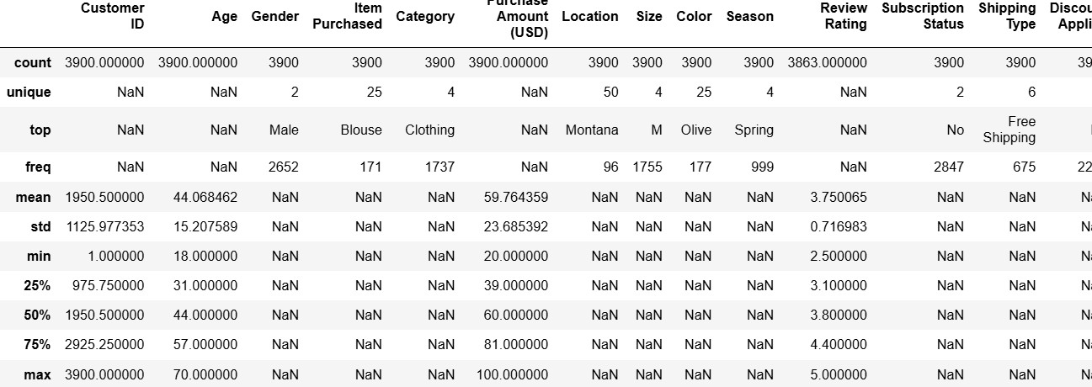

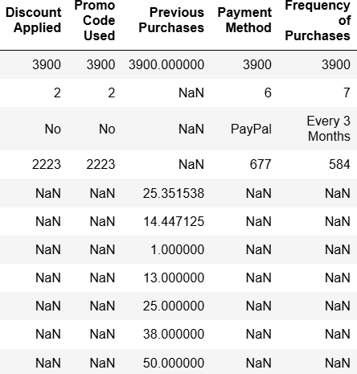

- Missing Data Handling: Checked for null values and imputed missing values in the
Review Rating column using the median rating of each product category.

- Column Standardization: Renamed columns to snake case for better readability and documentation.

Feature Engineering:

  - Created age_group column by binning customer ages.

  - Created purchase_frequency_days column from purchase data.

- Data Consistency Check: Verified if discount_applied and promo_code_used
were redundant; dropped promo_code_used.

- Database Integration: Connected Python script to PostgreSQL and loaded the cleaned DataFrame into the database for SQL analysis.

Data Analysis using SQL (Business Transactions)
We performed structured analysis in PostgreSQL to answer key business questions:

- Revenue by Gender – Compared total revenue generated by male vs. female customers.
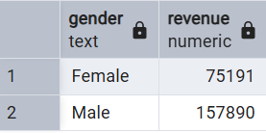

- High-Spending Discount Users – Identified customers who used discounts but still spent above the average purchase amount.
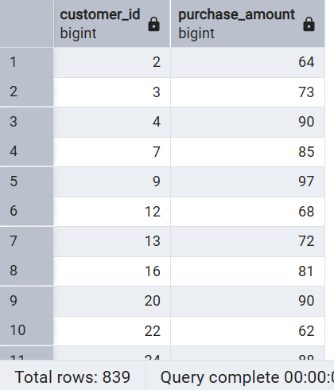

- Top 5 Products by Rating – Found products with the highest average review ratings.

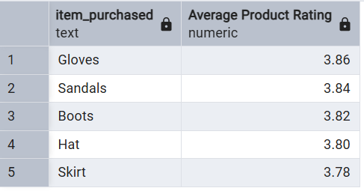

- Shipping Type Comparison – Compared average purchase amounts between Standard and Express shipping.
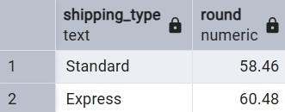

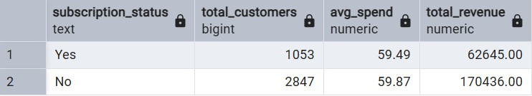
- Subscribers vs. Non-Subscribers – Compared average spend and total revenue across subscription status.

- Discount-Dependent Products – Identified 5 products with the highest percentage of discounted purchases.
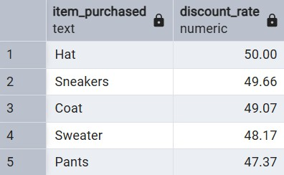

- Customer Segmentation – Classified customers into New, Returning, and Loyal segments based on purchase history.
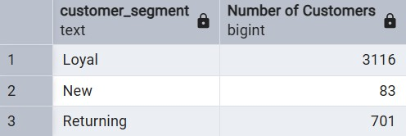

- Top 3 Products per Category – Listed the most purchased products within each category.

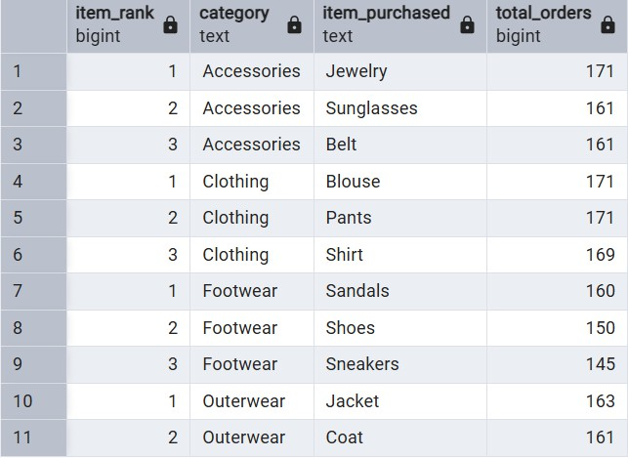

- Repeat Buyers & Subscriptions – Checked whether customers with >5 purchases are more likely to subscribe.
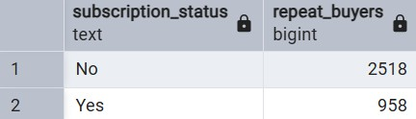

- Revenue by Age Group – Calculated total revenue contribution of each age group.
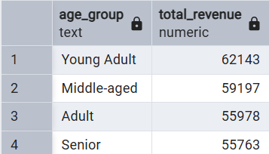

Dashboard in Power BI
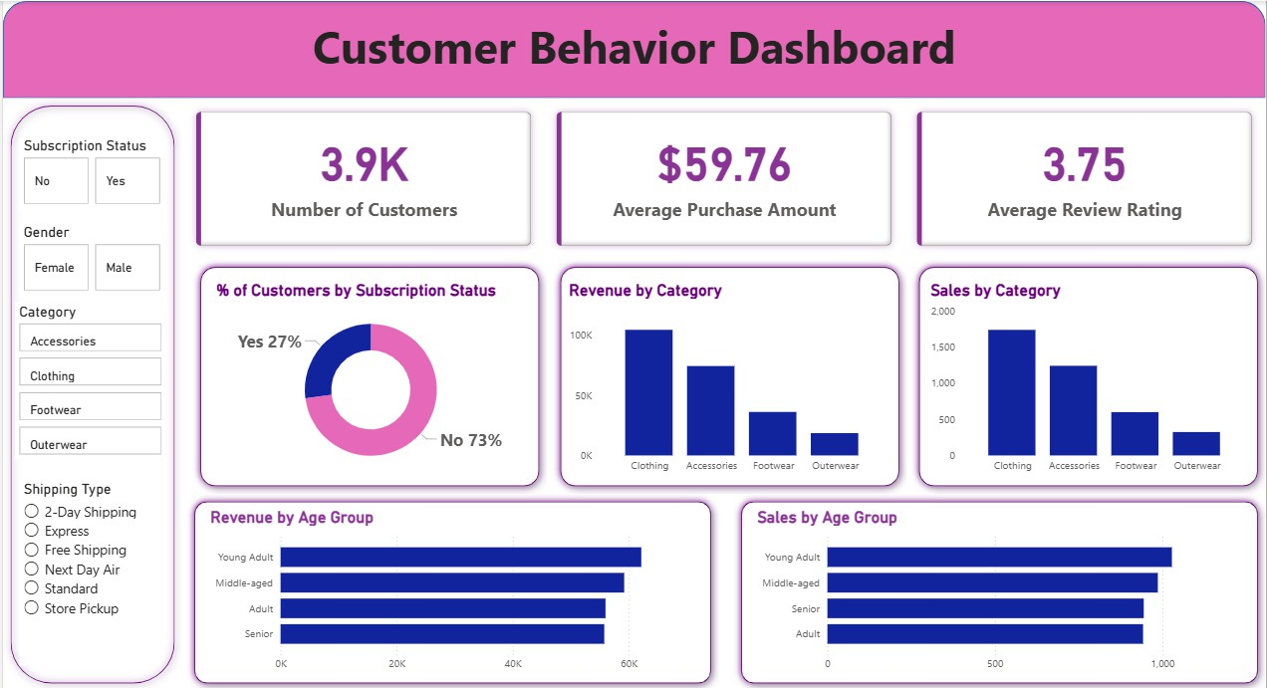
Finally, we built an interactive dashboard in Power BI to present insights visually.

Business Recommendations
- Boost Subscriptions – Promote exclusive benefits for subscribers.
- Customer Loyalty Programs – Reward repeat buyers to move them into the “Loyal” segment.

- Review Discount Policy – Balance sales boosts with margin control.

- Product Positioning – Highlight top-rated and best-selling products in campaigns.

- Targeted Marketing – Focus efforts on high-revenue age groups and express-shipping users.

Presentation
A stakeholder-facing slide deck summarizing the problem, approach, key findings, and recommendations was built using Gamma, for use in presenting the project to non-technical audiences.

Tech Stack
Python (pandas) · PostgreSQL · SQL · Power BI · Gamma

